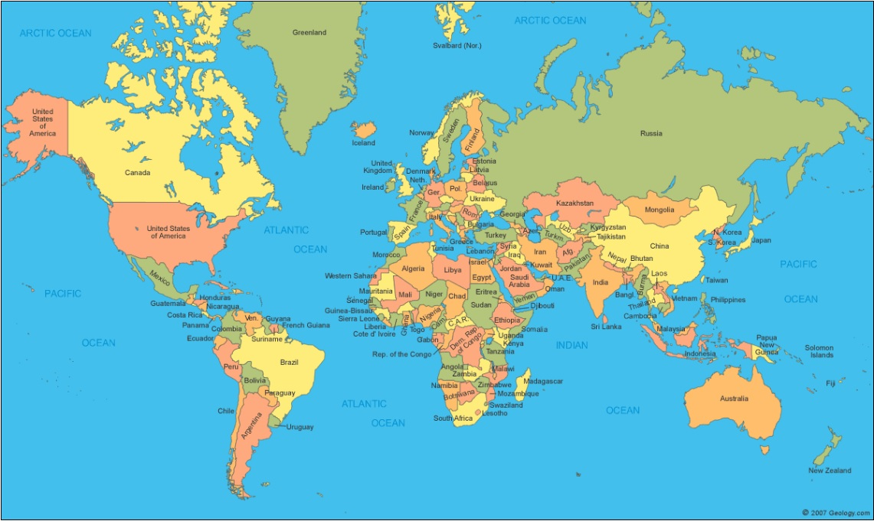

South Korea: [PIPA](https://www.privacy.go.kr/eng/laws_view.do?nttId=8186&imgNo=4)

USA: [FERPA](https://registrar.berkeley.edu/academic-policies-procedures/ferpa), [HIPAA](https://www.ucop.edu/ethics-compliance-audit-services/compliance/hipaa/)

Brazil: [LPGD](https://iapp.org/media/pdf/resource_center/Brazilian_General_Data_Protection_Law.pdf)

Argentina: [Personal Data Protection Law](http://www.jus.gob.ar/media/3201023/personal_data_protection_act25326.pdf)

European Economic Area:

[GDPR](https://ethics.berkeley.edu/privacy/general-data-protection-regulation-gdpr)

Canada: [PIPEDA](https://www.priv.gc.ca/en/privacy-topics/privacy-laws-in-canada/the-personal-information-protection-and-electronic-documents-act-pipeda/pipeda_brief/)

Switzerland: [FADP](https://www.edoeb.admin.ch/edoeb/en/home/the-fdpic/legal-framework/ii--a-few-facts-about-the-federal-act-on-data-protection.html)

g

Mexico:

[Federal Law on Protection of Personal Data Held by Private Parties](https://iapp.org/media/pdf/knowledge_center/Mexico_Federal_Data_Protection_Act_July2010.pdf)

Australia: [Privacy Act of 1988](https://www.oaic.gov.au/privacy/the-privacy-act/)

China:

[CSL and Information Security Technology -Personal Information Security Specification](https://www.chinalawblog.com/2020/07/chinas-personal-information-specifications-revised.html)

Russia:

Federal Law #s [152-FZ](https://pd.rkn.gov.ru/authority/p146/p164/) and [242 FZ](https://pd.rkn.gov.ru/authority/p146/p191/)

Japan: [APPI](http://www.japaneselawtranslation.go.jp/law/detail/?id=2781&vm=2&re=02)

South Africa: [POPIA](https://www.justice.gov.za/inforeg/docs/InfoRegSA-POPIA-act2013-004.pdf)

India: [Information Technology Act of 2000](https://www.meity.gov.in/content/information-technology-act-2000)

B.C.: [PIPA](https://www.oipc.bc.ca/guidance-documents/1438)

CA: [IPA](https://www.calhfa.ca.gov/privacy/ipa.pdf), [CCPA](https://ethics.berkeley.edu/privacy/california-consumer-privacy-act-ccpa), [CMIA](https://irb.ucsd.edu/cmia.pdf)